Declaration of Candidacy —
National Credit Union Foundation Board of Directors

2025 Nominations Process

The National Credit Union Foundation Board selection is based on the information provided in this Declaration of Candidacy.

Visit the Foundation’s website for resources to assist you in completing this form including the Board Member Agreement, 2024 Annual Impact Report, and Financial Statements.

The following five seats are up for nomination – one of them (Seat 1) is appointed; the remaining four (Seats 4, 7, 10, and 16) are open for election:

- Seat 1 – Appointed by America’s Credit Unions; Qualifications: Must be and remain an executive officer or director of an affiliated credit union.

- Seat 4 – Credit Union Executive or Director: Qualifications: Must currently be and remain an executive officer or director of a credit union.

- Seat 7 – Credit Union Executive or Director: Qualifications: Must currently be and remain an executive officer or director of a credit union.

- Seat 10 – Credit Union Executive or Director: Qualifications: Must currently be and remain an executive officer or director of a credit union.

- Seat 16 -- Credit union executive or director or system affiliate or at-large. Qualifications: Must be and remain (i) an executive officer or director of a credit union, or (ii) a director or executive officer of an organization that is national in scope, that has as its primary purpose support of credit unions or some element of the credit union movement, that has a significant portion of its ownership or membership from the credit union system and that has demonstrated a commitment to the purposes of the Foundation, or (iii) a representative of an organization outside of the credit union system that has demonstrated a commitment to the purposes of the Foundation (“At-large”). No more than two (2) of seats 13-17 may be “At Large” representatives.

Other eligibility requirements:
No current employee of America’s Credit Unions and its affiliate organizations (including The National Credit Union Foundation) or their family members shall be eligible for a Foundation board position. No former employee of America’s Credit Unions and its affiliate organizations or their family members, shall be eligible for a Foundation board position for a period of time from the date of last employment. “Family” shall be defined as spouse, parent, child, sibling, uncle/aunt, niece/nephew, grandparent, grandchild, or any of those or equivalent relationships arising as the result of marriage, civil union or domestic partnership.

Board Member Expectations and Commitment

Time and financial commitment:
- The Foundation Board meets for three in-person and one virtual board meetings each year, in addition to a virtual annual meeting. Board members are asked to attend all board meetings whenever possible.

- The Foundation requests the sponsor organization (e.g. the Director’s credit union, league, etc.) to pay for a Director’s travel expenses to Board meetings and other Foundation sponsored events as an in-kind donation to the Foundation acknowledging the sponsor’s commitment to the Foundation. Please reach out should this create a hardship on the Director’s sponsoring organization.

- Board members are asked to serve on two or three committees annually. The time commitment is typically 1-2 hours per meeting, with up to quarterly meetings for each committee. Board members are asked to attend all committee meetings whenever possible.

Fundraising commitment:
- The Foundation Board is primarily a fundraising board. Board members are expected to donate personally and solicit donations from their organizations and others to support the Foundation’s work as follows: (i) Board members traditionally give personal gifts between $100 and $5,000 annually to the Foundation; and (ii) Board members also are responsible for contributions from their own organizations and others. Please see the suggested giving levels below:
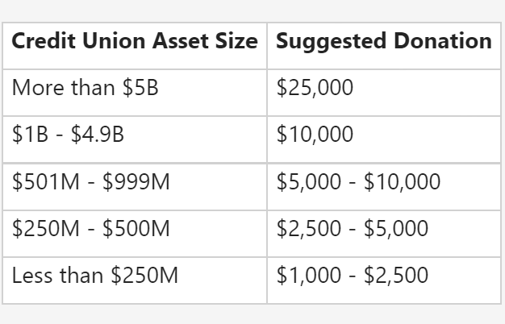

Criteria for Nominations

The following baseline criteria will be used to assess candidates:
- How will the candidate contribute to the ultimate achievement of the National Credit Union Foundation’s mission and vision?

- Individuals with specific experience in fundraising and nonprofit success may be targeted in recruitment. To that end, what specific skills does the candidate bring to the table (e.g., fundraising, program experience, contacts) that enhances her/his ability to support the Foundation?

Other criteria:
- Affiliation: The candidate’s employing or sponsoring entity is required to be an affiliate in good standing with America’s Credit Unions for a candidate’s ability to serve as a director.

- Diversity: The Foundation Board is committed to creating a diverse board while maintaining the ultimate goal of securing excellent candidates. Diversity encompasses all the characteristics, experiences and cultural influences that make each person unique. The collective sum of the individual differences, life experiences, knowledge, inventiveness, innovation, self-expression, unique capabilities and talent plays a significant part in the strength of the Foundation Board.

- Leadership: The Foundation Board is committed to the development of new leadership and the strengthening of alliances with different sectors of the credit union system. The Foundation Board views the annual nominations and elections process as an opportunity to fulfill this commitment.

- Application: The information requested on the following pages will be used to determine a candidate’s strength and eligibility for a seat on the Foundation Board of Directors.

The applicant may be interviewed at the Nominating Committee’s discretion.

Please return your completed Personal Data Form and the Nomination Questionnaire, along with the one letter of recommendation to support your nomination electronically, by email, to:

Lauren Culp, Executive Director, National Credit Union Foundation
Subject: Declaration of Candidacy for Foundation Board
Email: lculp@ncuf.coop

If you have questions, please reach out to Ms. Culp via email.
Declaration of Candidacy —
National Credit Union Foundation Board of Directors

Personal Data Form
Please print or type.

Candidate Name

Candidate Title

Credit Union or Organization

Address City State ZIP

Phone

E-mail

___________________________
Seat Number you are applying for

I acknowledge that I have read and agree to the following listed above in the Board Member Expectations and Commitment: (please initial)

_____ Time commitment

_____ Financial commitment

_____ Fundraising commitment

Signature of Candidate Date

Nomination Questionnaire

Please provide as much information as possible in each area. Use additional pages if necessary.

- Explain in 200 words or more how you, as a director, would contribute to the ultimate achievement of the National Credit Union Foundation’s mission and vision.

- Please list your involvement on charitable or philanthropic (e.g., foundations, charity, etc.) boards or non-credit union related organizations. Include years served.

- Please list your involvement on the state and national level committees or organizations within the credit union movement. Include years served.

- How many years have you worked and/or volunteered in the credit union movement?

- In 100 words or less, please provide any specific skills (e.g., fundraising, program experience, contacts) or additional information not already mentioned above that would be relevant to your candidacy for the National Credit Union Foundation Board of Directors.

Nomination information becomes the property of the Foundation and will not be returned. All nomination materials will remain confidential.

